Delayed Payments, Heavy Debt: Indian MSMEs Fighting A Long Battle
Rising bad loans ignites the importance of modernising debt collection practices for MSMEs that can provide financial stability and growth to India's small businesses.
.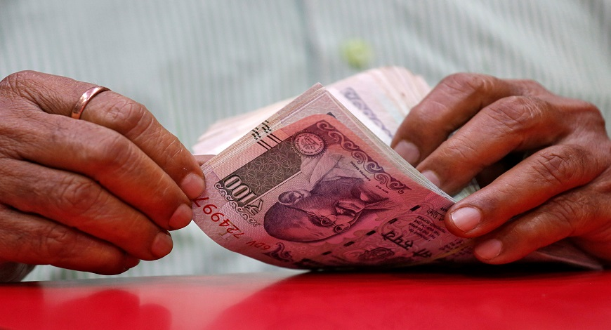
31July, 2023 by Abhishek Sharma

Access to long-term credit, delayed payments and heavy debt are the problems that India's micro, small and medium enterprises (MSMEs) deal with every single day, especially after the deadly Covid-19 pandemic and the negative impact Russia- Ukraine war.
In the last two years, Indian MSME credit demand has grown 1.7 times and non-banking financial companies (NBFCs) alone witnessed a two times demand in the same period. The current credit exposure of the MSME sector is Rs 22.6 lakh crore, a 12.3 per cent year-on-year (YoY) growth. The outstanding MSME advances of 12 public sector banks (PSBs) have jumped from Rs 9.28 lakh crores in FY20 to Rs 11.48 lakh crore in FY23.
Notably, a joint report by Assocham and Crisil showed that bad loans of Indian banks will decrease by one percentage point in this financial year but bad loans in the MSME industry could rise to double-digit levels. The report added that gross non-performing assets (NPAs) will decline below four per cent by March 2024.
Experts told BW Businessworld that the rise in bad MSME loans in India is due to factors such as the impact of slowing exports, the slowdown in certain global markets, sectors, withdrawal of Covid-19 concessions and rising interest rates.
"MSMEs, especially the smaller ones, often lack sufficient assets or collaterals to secure business loans. As a result, they may resort to unsecured loans, which increases the risk for lenders. The lack of adequate understanding of the advanced financial technology capabilities used by many non-banking financial companies (NBFCs) and online lenders is also a significant challenge, contributing to rising loan defaults," said Rishabh Goel, Co-founder and CEO, Credgenics.
In response to the rising defaults, banks have approached the Reserve Bank of India (RBI) to ease MSME rules for resolution. "One potential solution is to consider restructuring of such MSME accounts under the Covid package, as non-performing assets (NPAs) from the latest date and not from the date prior to restructuring, which could provide some relief to the sector. Addressing these issues through targeted policies and support measures may help mitigate the problem," added Goel.
Modernising debt collection
Department of Financial Services (DFS) data revealed that about 17.27 lakh micro-enterprise segments in India, which used the government's credit under the emergency credit line guarantee scheme (ECLGS) out of total borrowers, have turned non-performing assets (NPAs) as of 24 March 2023.
In India, the MSMED Act provisions for the MSMEs to be paid within 45 days of the acceptance of the invoice. Acceptance of invoices construes that the quality and quantity of the products delivered are as per the agreed terms, however, MSMEs still face delayed payments, resulting in the larger issue of defaults.
"The delayed payment of MSMEs is not out of choice but due to their debtors/buyers who delay payment. In India and across the globe there’s a systemic problem of the larger buyer using the money due to SMEs as an interest-free working capital. We have seen how disruption to the smallest supplier in the supply chain can cause disruption to the assembly line of a larger OEM," said Kalyan Basu, MD & CEO, Vayana TradeXchange, Vayana (IFSC).
Experts said that rising bad loans and other issues faced by the MSME sector ignite the importance of modernising debt collection practices for MSMEs which comes with the potential benefits it can bring to their financial stability and growth.
"Factoring serves as a powerful financing tool for MSMEs, addressing their working capital needs in the absence of hard collateral required by banks. By aligning with their sales and trade cycles, factoring becomes an ideal risk mitigant for these businesses as it substantially reduces collection and repayment risks by ensuring direct payments from MSME buyers to the lender, mitigating commingling risk and providing early warning signals for delayed collections," said Saini Rajgopal, Co-founder, Artfine.
Despite the Finance Ministry's directive to ensure timely payments to MSMEs within 45 days, delays persist due to their small size and limited bargaining power with buyers. Here, factoring plays a pivotal role by instilling a sense of responsibility in buyers to pay on time, as lenders actively monitor the processes, added Rajgopal.
Traditional debt collection methods, which heavily rely on manual processes and limited technology, often lead to inefficiencies, delays, and a poor experience for both creditors and debtors. By embracing modernisation and integrating technology, the debt collection industry can address several critical challenges and improve its overall effectiveness.
"Streamlining the debt collection process for MSMEs can significantly improve their credit profile, boost their creditworthiness, and reduce risk perception among lenders. This, in turn, allows MSMEs to avail credit at ease, with access to better financing options, faster loan approvals, and the potential for higher loan amounts. Ultimately, this helps MSMEs secure the necessary capital to thrive and contribute positively to the economy," Credgenics' Goel mentioned.
There have been various reports on the whopping Rs 10.7 lakh crore working capital locked up in the delayed payment from buyers to suppliers – an estimated 7.8 per cent of the gross domestic product (GDP). About 80 per cent of this amount is owed to the MSMEs in the country, totalling Rs 8.55 lakh crore.
"There is a need to empower more on alternative solutions like cash-flow-based lending that has picked up pace in the past few years. Empower MSMEs with cash flow-based lending through government-sponsored credit guarantee schemes. Extend the reach with state-level credit guarantee schemes in collaboration with fintech companies, focusing on specific regions. Maximise support by harnessing the joint initiative of the World Bank and the government, the RAMP scheme, said Basu.
Basu added that the Credit Guarantee Fund Scheme for Factoring (CGFSF) by the government reduces banks' risk aversion. It promotes 'factoring without recourse' by offering a credit guarantee cover where factors bear ten per cent of the amount in default, and the NCGTC and Factors share the remaining 90 per cent in a 2:1 ratio.
"Timely collections of receivables can alleviate cash flow challenges faced by MSMEs. In this regard, revenue-based funding emerges as a more effective approach than traditional term lending which may not align with the dynamic realities of on-the-ground business operations," Artfine's Rajgopal asserted.
Meanwhile, experts pitched for the integration of CGFSF with TReDS which will boost financial institutions' risk appetite to discount lower credit-rated invoices (BBB and lower) which will push buyers to transact on the platform.

