NBFC Sector in India Sees Significant Changes After HDFC Merger: Expert
According to the rating agency ICRA, the growth outlook for FY2024 has been revised to 18-20 per cent, up from the previous estimate of 12-14 per cent
...
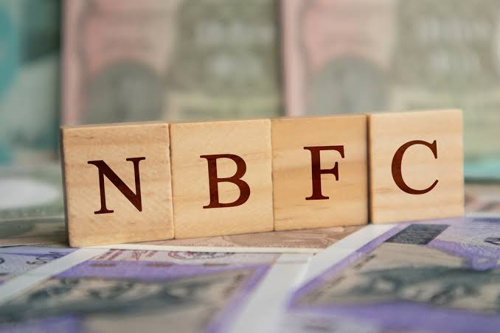
by
28July, 2023 by Rajany PradhanAds

The landscape of the Non-Banking Financial Companies (NBFCs) in India has undergone significant changes, particularly in the wake of the merger of HDFC and its potential impact on the securitisation market. According to the rating agency ICRA, the growth outlook for FY2024 has been revised to 18-20 per cent, up from the previous estimate of 12-14 per cent. The key driver behind this surge is the unsecured loan segment, which continues to expand. This significant growth signals a positive shift in the Indian financial landscape, attracting both traditional and new-age NBFCs to explore innovative opportunities in the market.
Arvind Rangarajan, TCA - co-founder of Arth Padarth Factors & Finance (Artfine group), said, “HDFC’s absence creates a significant void in the credit and liquidity space. Traditional players stand to benefit, given their established risk profiles. New-age NBFCs are still developing their presence in capital markets. Instruments like Pass Through Certificates backed by credible credit enhancements and higher ratings, could witness increased demand.”
However, this effect stems from a combination of factors. Arvind shared, “SEBI’s regulations, which have an incentive edge on private credit funds through AIF route and the rising need for higher-yielding assets, and not solely HDFC's departure. As the market adapts, various players will navigate and capitalise on opportunities.”
Krishan Gopal, CFO, Aye Finance, shared, “In line with the NBFC Growth Estimates, securitisation market would also be robust for the unsecured loan segment, specifically for the unsecured small enterprise loans and microfinance loans.

